Data Management Plan :

Summary of Data to Store:

1. User Data: User ID Username Email Password (hashed and salted) Profile Information (name, address, contact information)
2. Customer Orders Data: Order ID Customer ID (foreign key) Order Date Order Status Order Details (products, quantities, prices) Payment Information (credit card details, PayPal, etc.)
3. Inventory Data: Product ID Product Name Product Description Quantity in Stock Price Supplier Information
4. Help Assistance and Live Chat Data: Chat ID User ID (customer) Agent ID (admin) Message Content Timestamp ER Diagram:

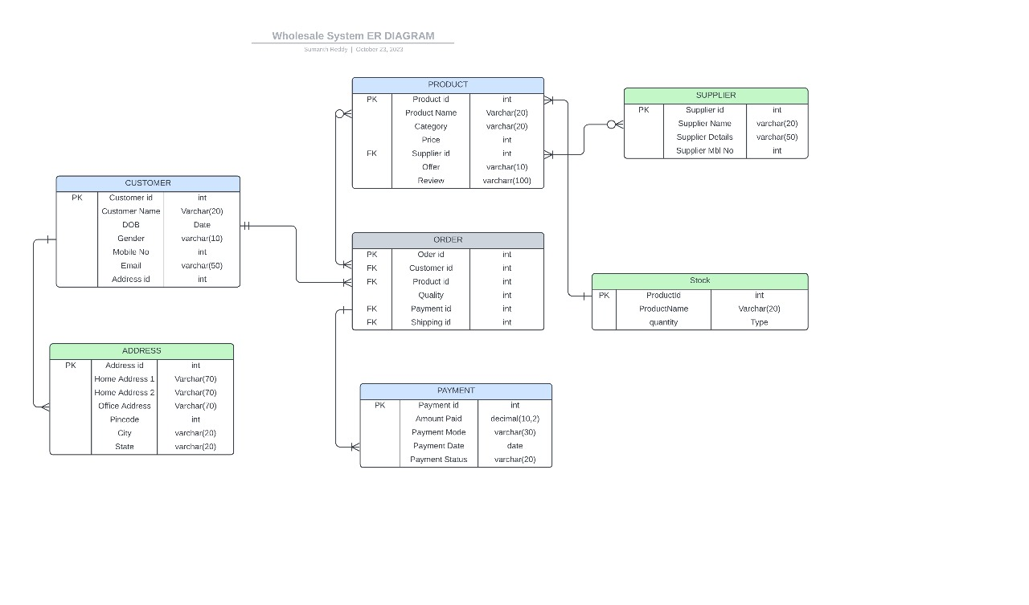

Initial Data Security Plans: Access Restriction: Implement role-based access control to ensure that only authorized users can access certain parts of the system. Admins have access to inventory management and active orders, while customers can manage their profile and place orders. Encryption: Sensitive data like user passwords and payment information should be encrypted during transmission (using HTTPS) and storage (using encryption algorithms like AES). Mapping of Functional Requirements to Data Storage:

1. User Authentication and Registration: User data is stored for authentication and registration. The user table stores user IDs, usernames, email addresses, and hashed passwords.
2. Password Reset Email: Email addresses are stored to send password reset emails. A secure mechanism is used for this process.
3. User Profile Management: User profiles are stored in the user table, including name, address, and contact information. Users can create, update, and view their profiles.
4. Customers Order and Payment Management: • Customer orders are stored in the order table, including order details and payment information. Each order is linked to the customer's ID.
5. Help Assistance and Live Chat: Live chat data is stored, including user IDs (customer and admin), chat messages, and timestamps.
6. Admin Authentication and Inventory Management: Admin authentication is managed similarly to user authentication. Admins can update inventory, which is stored in the inventory table with product details and quantities.
7. Stock Details and Active Orders Monitoring: Stock details, including product names, quantities, and supplier information, are stored in the inventory table. Active orders are tracked using the order status field in the order table. This data management plan outlines what data is required, how it is structured, initial security measures, and how it aligns with the project's functional requirements. This is a crucial step in ensuring that the data is managed effectively and securely in the wholesale system project.